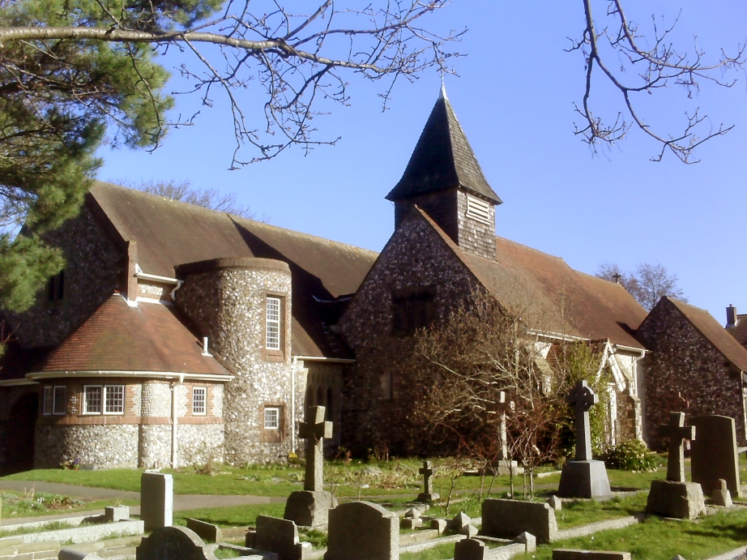

INVESTMENT POLICY

MARCH 2020

St Peter’s West Blatchington
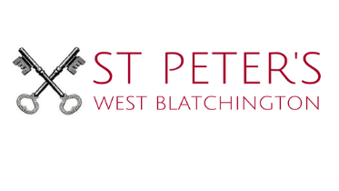

Purpose
This document sets out the Investment Policy for St Peter’s Church, West Blatchington, (SPC) in order to provide guidance for trustees charged with making investment decisions to ensure that the financial resources of the church are managed effectively and in line with the aims and goals of the church.

Introduction
The Parochial Church Council of St Peter's, West Blatchington (the PCC), is an incorporated charity, whose purpose is the promotion of the Gospel of our Lord Jesus Christ according to the doctrines and practices of the Church of England. The PCC has the responsibility of promoting within the ecclesiastical parish the whole mission of the Church: pastoral, evangelistic, social and ecumenical.

St Peter’s Church also contributes to the maintenance and some of the running costs of the Rectory in Windmill Close, which is owned by the Diocese of Chichester.

Investment Objectives
The primary investment objective for the long-term Investment reserves is to maintain a return at least equal to the prevailing rate of inflation, in order to prevent the value of the church’s financial assets depreciating.

A secondary objective is to generate an income from the investments to support the maintenance and ongoing activities of the church.

Risk Appetite
To achieve its investment objectives, the PCC are prepared to accept a Medium level of Risk; this means being prepared to accept some short-term fluctuations in the value of investments, in order to try and achieve better long-term returns, while avoiding high risk investments that have the potential to incur significant losses.

Ethical Investment Policy
The PCC has adopted an ethical investment policy to ensure that its investments do not conflict with its wider aims. The PCC has adopted the recommendations of the Church of England Investment Advisory Group. More details can be found here - https://www.churchofengland.org/eiag

Assets
The PCC’s long-term assets are largely invested in the Central Board of Finance (CBF) Investment fund. This fund is managed in a way that is consistent with the PCC’s risk appetite, investment objectives and ethical investment policy.

This investment fund comprises an actively managed, diversified portfolio of assets designed to help protect both present and future beneficiaries from the effects of inflation. It will mainly invest in equities, but will also include property, bonds and other asset classes. It is suitable for a Church of England charity’s long-term funds where the charity is looking for a good level of distributions and long-term protection from inflation.

The CBF Investment fund is managed in accordance with the policies of the Church of England’s Ethical Investment Advisory Group.

Currency
All activities of the Church are conducted in the UK. Consequently, in order to protect against currency risk, the base currency of the investment portfolio is Sterling.

Liquidity Requirements
Income from the long-term reserves will be used to fund the PCC’s activities. Due to the nature of the reserves, the PCC wish to keep at least 90% of the long-term reserves in investments that can be realized within three months. All the short-term reserves should be realizable within one month.

Banking Policy
Short-term assets will be held in Cash in an appropriate Bank Account. The PCC has chosen CAF Bank to be its provider of choice, as it has a competitive charging structure, is specifically designed for use by charitable organizations, and its profits are used to support charitable causes.

Responsibilities
The Treasurer of the PCC, as the person with access to both the Investment and Bank Accounts, is responsible for the day to day administration of the Church’s investments. Decisions about changes to the Investment Policy will be made by the PCC. Reporting on the performance of the investments forms part of the regular Treasurer’s reports.

Monitoring and Review
The Investment Policy of the Church of St Peters, West Blatchington will be reviewed by the PCC or an appointed investment adviser every 24 months. The next review is due in March 2022.

